# TicTacToe

## What is TicTacToe?

TicTacToe is a 2 player game played on a 3 x 3 board. Each player is allotted a symbol (one X and one O). Initially, the board is empty. Alternatively, each player takes a turn and puts their symbol at any empty slot. The first player to get their symbol over a complete row OR a complete column OR a diagonal wins.

You can play the game within Google Search by just searching for “tictactoe”!

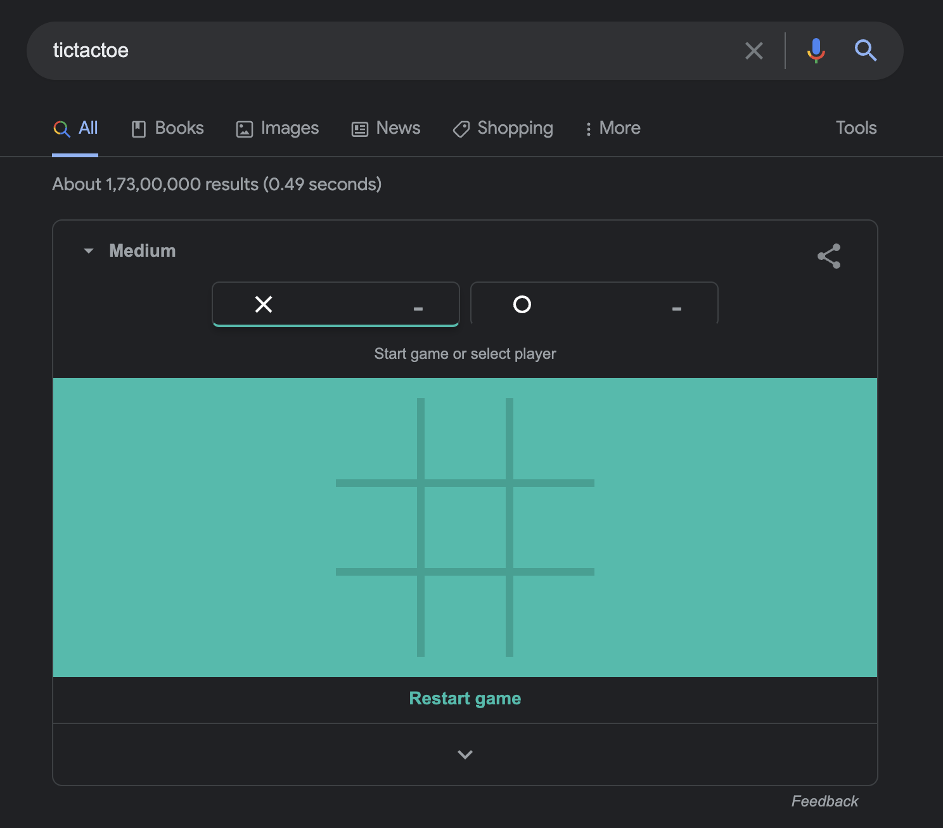

## Questions to Ask

* Will the game be played amongst only 2 players or can there be any number of players in future?
* Is the board size restricted to 3x3 or can it be any NxN?
* Feature Suggestions:
  + Do we want to time a move? Skip/ Declare the other person as winner if the move doesn’t happen within x seconds.
  + Do we want to support undo operation?
  + Can there be some players who are just watching? Not playing.
  + Do we want to store analytics? Basically previous games, who played what move etc.
  + Can one of the players be a bot?
  + Support for tournaments? Basically a set of matches, each match between 2 players of the tournament.
  + Can there be different ways to win?

## Expectations

* The code should be working and functionally correct
* Good software design practices should be followed:
  + Code should be modular, readable, extensible
  + Separation of concern should be addressed
  + Project structured well across multiple files/ packages
* Write unit testsNo need to create
* No need of GUI

## Problem Requirements

* Board can be of any NxN size.
* There can be any number of players. Each player will be allotted a symbol.
* The players can be either humans or bots. Each human player will have a name.
* We should allow support to undo any number of moves.
* Try to implement the winner detection algorithm in O(1).

## Interaction Format

Command Line based interactive application.

### Input/ Outputs

#### Game Start

Allows to start the game with a given number of players, board size, and symbols of every player.

| StartGame [Number of Players] [... User ID and Symbol for each player separated by space ...] [Board Size] |
| --- |

Example:

| StartGame 2 u1 X u2 O 3 |
| --- |

If a player is a computer, their user id will be C.